**PLATFORM FOR EDUCATING FARMERS ON AGRICULTURE**



**SUBMITTED BY,**

**HARUN KAMANDE IRUNGU**

**DIT-01-8187/2023**

**A SYSTEM DOCUMENTATION AND SUBMITTED IN PARTIAL FULFILMENT FOR THE AWARD OF A DIPLOMA IN INFORMATION TECHNOLOGY BY ZETECH UNIVERSITY**

**APRIL, 2024**

Declaration

The contents of this document are a product of my own personal research as guided by the unit lecturer and following the provided standards of the system proposal document. No content has been plagiarized and all foreign sourced materials have been properly cited and referenced using the APA 7 standard. This document has not been presented or submitted to Zetech University or to any other body in this version. It is an original version.

Student name: __________________________________ Sign: __________________

Supervisor’s name: ______________________________ Sign: __________________

Unit lecturer’s name: _____________________________ Sign: __________________

# DEDICATION

I dedicate this work to my beloved mother, sister, and brothers, whose consistent support and love have been my greatest strength. Their encouragement and sacrifices have fueled my determination and their unshakeable belief in me has been my inspiration.

ACKNOWLEDGMENT

I would like to thank my unit lecturer, Mr. Francis Mutuku, for assisting me in reflecting on different research problems, identifying a feasible one, and coming up with a viable research topic. His weekly class and individual guidance were invaluable in conducting research, gathering data, compiling the system proposal document to its end, and writing the system documentation. I would also like to extend my gratitude to my supervisor, Mr. Kavoi, for his insightful feedback and support throughout the development of this project. His expertise and encouragement were crucial in refining the project and ensuring its successful completion. Additionally, I appreciate the support and understanding of my family and friends during this process. Their encouragement and patience provided me with the motivation to complete this work. Thank you all for your contributions and support.

# Abstract

The system helps farmers learn better about farming by giving them easy access to learning materials and training. This ensures that farmers have the right information to make good decisions and use the best farming methods. Teaching farmers about modern practices helps them grow more food in a way that's good for the environment. This doesn't just help farmers, but also makes rural communities stronger. By giving farmers knowledge and skills, we can make farming better and help rural areas grow economically. Technology is really important in this system because it makes learning easy for everyone. With technology, more farmers and rural communities can learn from educational resources and training. This system has the potential to change farming education and make farming communities thrive..

# List of figures

Figure 1: simple login page 10

Figure 2: Login UI code 10

Figure 3 create account page 11

Figure 4: Account creation UI code 12

Figure 5: HOMEPAGE 13

Figure 6: Home page UI code 14

Figure 7: post content 15

Figure 8: Content posting UI code 16

Figure 9: content page 17

Figure 10: Content page UI code 18

Figure 11: profile page 19

Figure 12: Profile page UI code 20

Figure 13: My post UI code 21

Figure 14: reply UI code 22

Figure 15: reply view UI code 23

Figure 16: Post editing UI code 24

Figure 17: video content ui code 25

Figure 18: photo ui code 26

Figure 19: backend code for create account 29

# Table of Contents

DEDICATION iii

Abstract v

List of figures vi

Table of Contents vii

Chapter one: System Overview 1

1 Research Problem 1

1.1 System objectives 1

1.1.1 General objectives 1

1.1.2 Specific objectives 1

1.2 System Scope 1

1.3 System Justifications 2

Chapter Two: High Level Design 3

2.1 : FRONT END (USER INTERFACE) IMPLEMENTATION 3

2.1.0 Login page 3

2.1.1 Create account page 4

2.1.2 Home page 6

2.1.3 Post page 8

2.1.4 Content page 10

2.1.5 Profile page 12

2.1.5.1 Profile page UI code 13

2.1.7 my post 13

2.1.7 Reply section 15

2.1.7.1 Reply UI code 15

2.1.8 Viewing replies 16

2.1.9 Post editing 17

2.1.9.1 Post editing UI code 17

2.1.10 video content 18

2.1.10.1 video content UI code 18

2.1.11 Posted photo 19

2.1.11.1 photo UI code 19

Chapter Three: Back End (Logic ) Implementation 20

3.1 Account Creation Process 20

3.1.1 Account creation Code 22

22

3.2 Log in Process 23

3.2.1 Login logic Code 24

3.3 Content Posting 25

3.4: Database Implementation 26

3.4.1 Normalization 26

3.4.1 Database Tables 29

3.4.2 System-to-Database Integration 31

**CHAPTER FOUR: CONCLUSION AND RECOMMENDATIONS** 33

4.1 conclusion 33

4.2: Recommendation 34

References 35

# Chapter one: System Overview

## Research Problem

In my community, there exists a gap in access to quality education and information on farming practices. Farmers and often lack access to comprehensive resources and training programs that can enhance their knowledge and skills in agriculture. This hinders agricultural productivity, sustainability, and innovation. As a result, it is clear that there is a need for a platform that can effectively deliver educational content and training to farmers and the public, addressing their specific needs and challenges.

## System objectives

### 1.1.1 General objectives

To propose and develop a comprehensive platform for educating farmers on agriculture

### 1.1.2 Specific objectives

1. To develop a digital platform to deliver educational content programs satisfying farmers’ needs.
2. To implement interactive tools and resources that can enhance the knowledge and skills of farmers in modern farming practices.
3. To create a feedback mechanism that allows farmers to ask questions, share experiences, and receive advice.

## System Scope

The proposed platform aims to address the educational gap in farming practices by providing a comprehensive digital solution focused on delivering high-quality educational content. The system will include the following key components:

1. **User Registration and Authentication**: The platform will include a secure registration and login system, allowing users to create accounts and access personalized content.**Educational Content Delivery**: The platform will offer various types of educational resources:
   * **Written Text Content**: Detailed articles and guides on modern farming techniques and best practices.
   * **Image Content**: Visual aids, diagrams, and photos to complement the written content and provide visual understanding of farming practices.
   * **Video Content**: Informative videos, including tutorials and demonstrations, to provide practical knowledge and visual instructions.
2. **Feedback Mechanism**: A robust feedback system will be implemented to enable farmers to ask questions and share experiences.
3. **Mobile Compatibility**: Recognizing the widespread use of mobile devices, the platform will be optimized for mobile access, allowing farmers to access educational content anywhere..
4. **Scalability and Maintenance**: The platform will be designed with scalability in mind to accommodate future growth and will include maintenance plans to ensure its continuous operation and relevance.

## System Justifications

The system helps farmers learn better about farming by giving them easy access to learning materials and training. This ensures that farmers have the right information to make good decisions and use the best farming methods. Teaching farmers about modern practices helps them grow more food in a way that's good for the environment. This doesn't just help farmers, but also makes rural communities stronger. By giving farmers knowledge and skills, we can make farming better and help rural areas grow economically. Technology is really important in this system because it makes learning easy for everyone. With technology, more farmers and rural communities can learn from educational resources and training. This system has the potential to change farming education and make farming communities thrive..

# Chapter Two: High Level Design

## 2.1 : FRONT END (USER INTERFACE) IMPLEMENTATION

### 2.1.0 Login page

The figure below represents a login page interface, This is the landing page of my system.

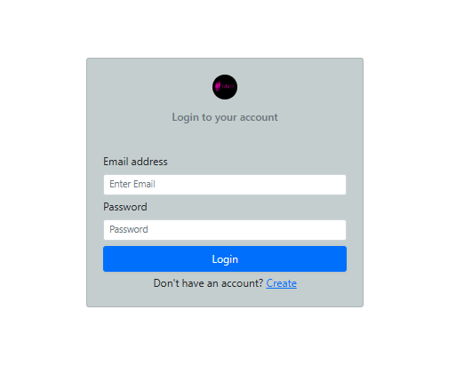

Figure 1: simple login page

#### 2.1.0.1 Login generator code

This UI code generated the login page

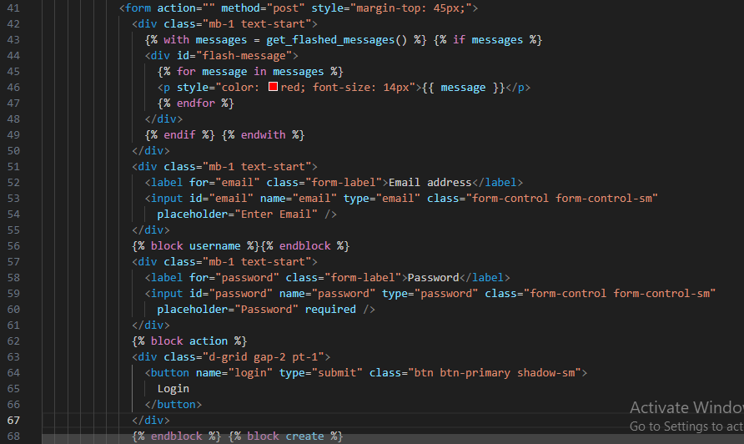

Figure 2: Login UI code

### 2.1.1 Create account page

Below represent account creation page of my system. For you to log you must have ever passed through this page.

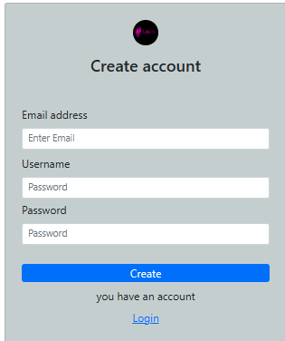

Figure 3 create account page

#### 2.1.1.1 Create account page

Below is create account ui code, it doesn’t have many lines of code as the login page, this is because it has inherited login page

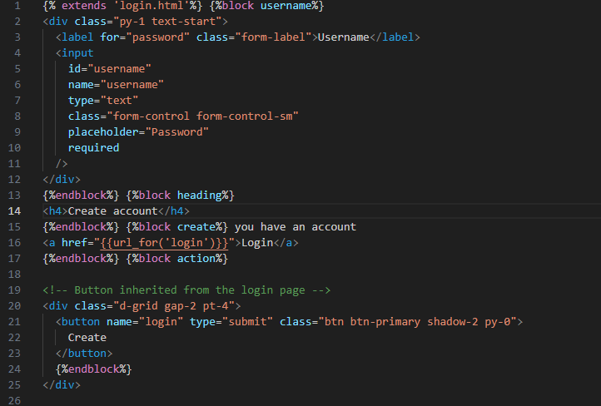

Figure 4: Account creation UI code

## 2.1.2 Home page

This is what my system will display incase you provide valid credentials in the login page.

The header which is black in color, should appear in in every page once the user log in

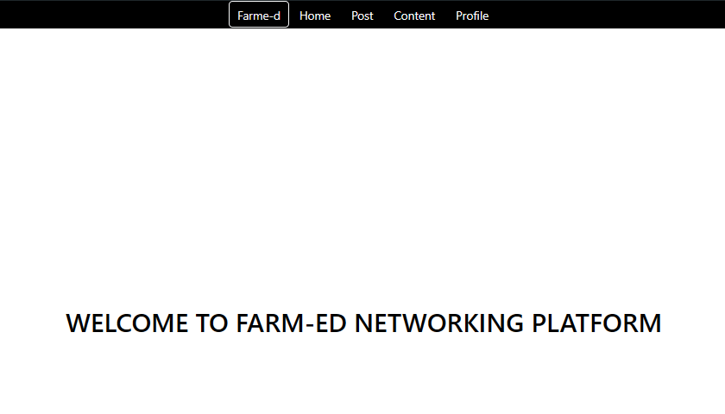

Figure 5: HOMEPAGE

#### 2.1.2.1 Home page UI code

Home page generator code

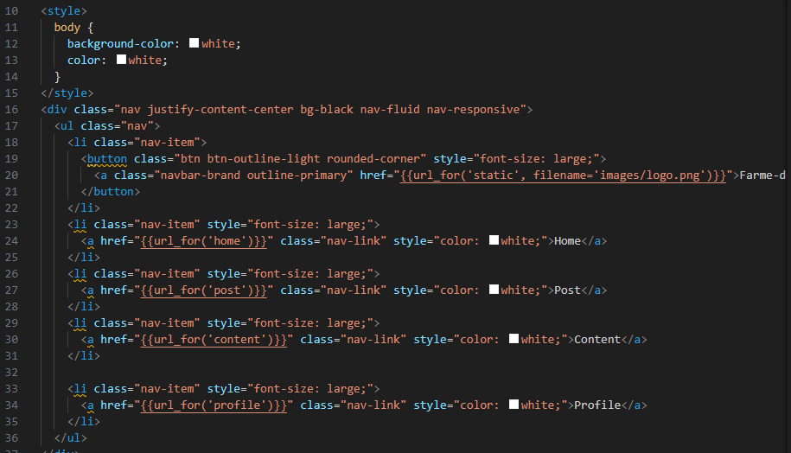

Figure 6: Home page UI code

## 2.1.3 Post page

Figure below show the post page, every user can post his content using this template, he can also decide to use to insert file which are videos and images or even text messages. Unlike text content/message file content is optional.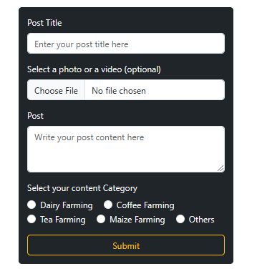

Figure 7: post content

#### 2.1.3.1 Post page

The figure below shows Post page UI code

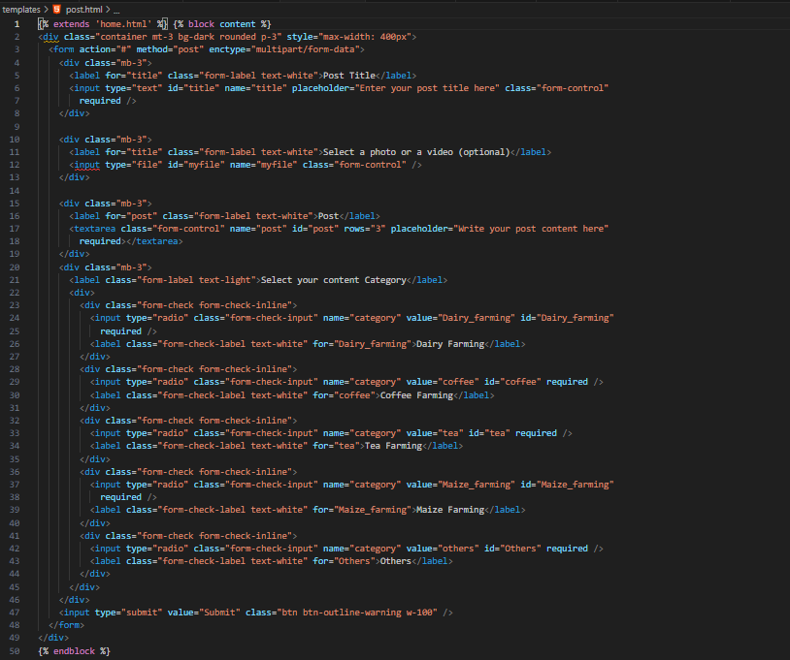

Figure 8: Content posting UI code

## 2.1.4 Content page

Below is a sample of a posted content in my system

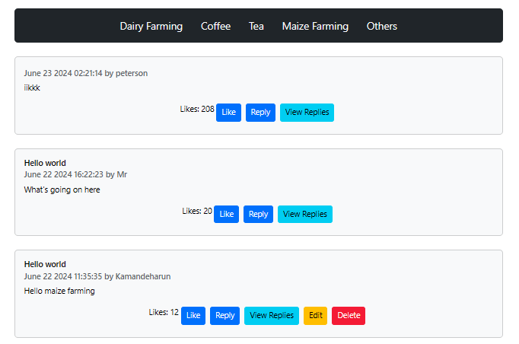

Figure 9: content page

#### 2.1.4.1 Content page UI code

All the posted content will be sent in content.html template. The jinja(written in python format) will check the type of content sent by the backend, the content can be in text,video or even image, it will later display the content in different format.

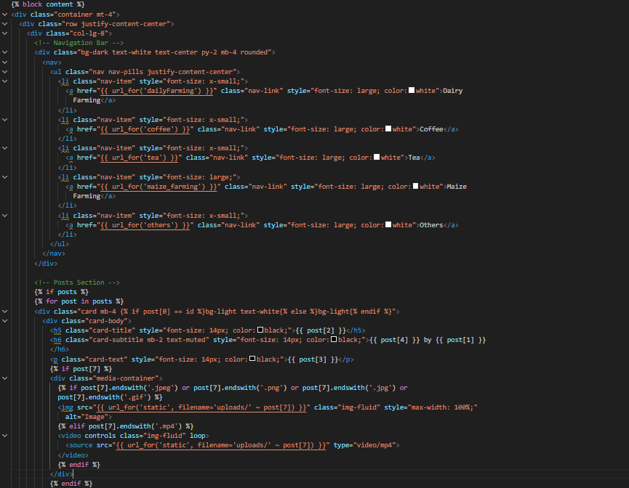

Figure 10: Content page UI code

## 2.1.5 Profile page

Below is a sample of a profile page

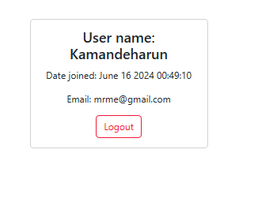

Figure 11: profile page

## 2.1.5.1 Profile page UI code

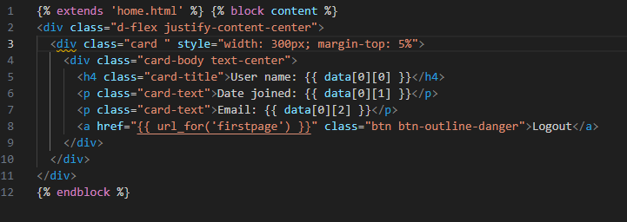

Figure 12: Profile page UI code

### 2.1.7 my post

Below is the display of my own post (post that ive posted)



#### 2.1.7.1 my post

This is the code being used to indicate your own posts in the system

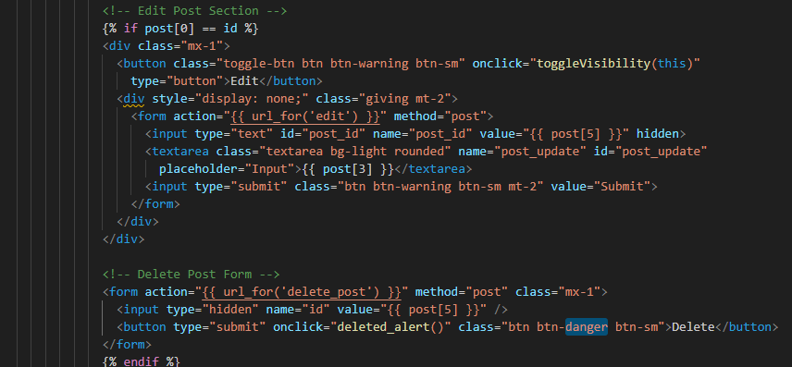

Figure 13: My post UI code

### 2.1.7 Reply section

Below is the reply section

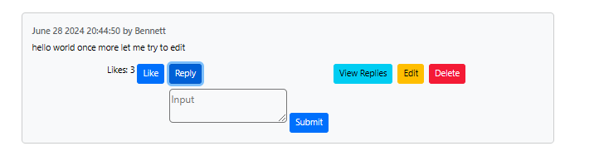

### 2.1.7.1 Reply UI code

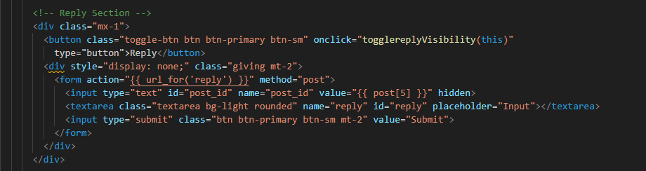

Figure 14: reply UI code

### 2.1.8 Viewing replies

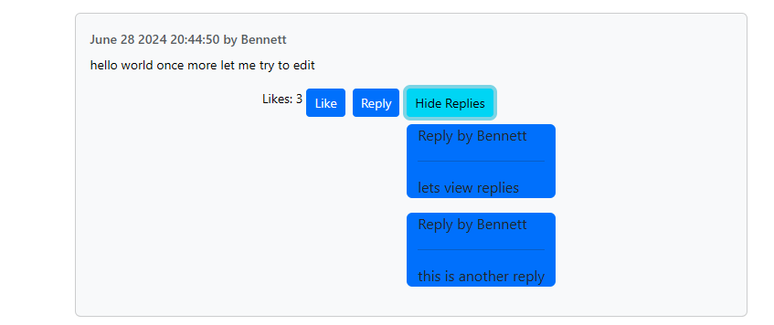

2.1.8.1 Reply view UI code

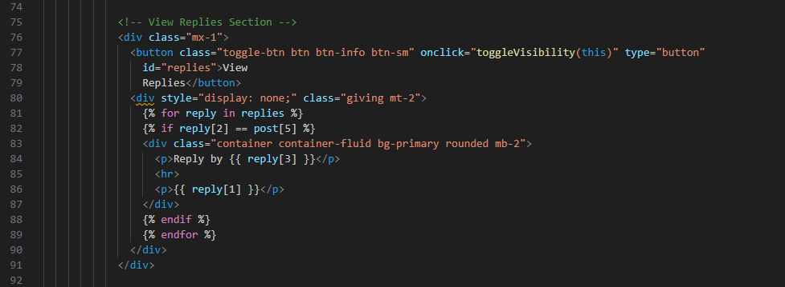

Figure 15: reply view UI code

### 2.1.9 Post editing

Below is editing functionality (incase the post is yours ), deletion of the post is available as well

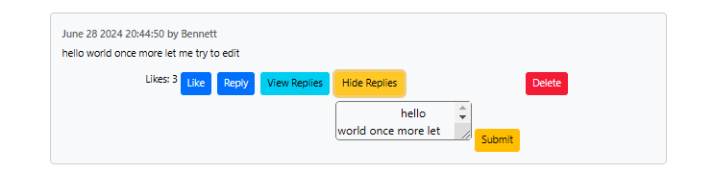

### 2.1.9.1 Post editing UI code

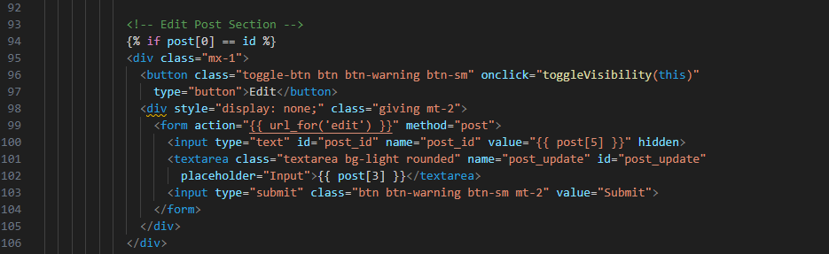

Figure 16: Post editing UI code

### 2.1.10 video content

Below is how posted video will look like

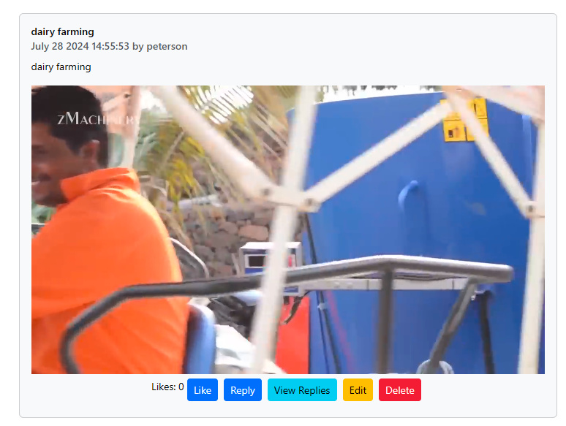

### 2.1.10.1 video content UI code

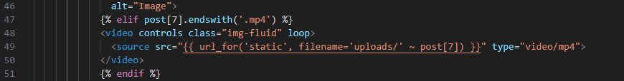

Figure 17: video content ui code

### 2.1.11 Posted photo

This is how posted images will appear

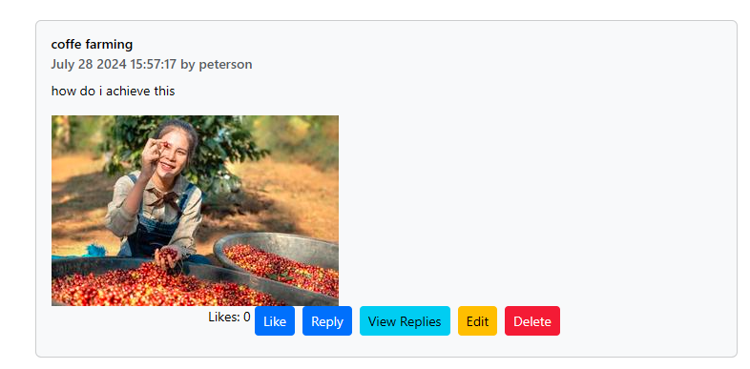

### 2.1.11.1 photo UI code

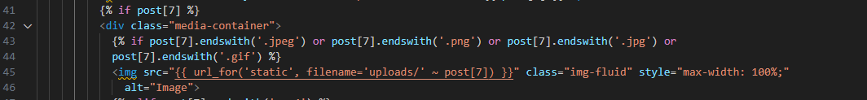

Figure 18: photo ui code

# Chapter Three: Back End (Logic ) Implementation

## 3.1 Account Creation Process

Below is the pseudocode illustrating the account creation Process

User Enters his credentials (Email,username,Password)

The user clicks the Create Button

System will check whether the account already exist(it will check whether the Email exists in the DB)

If the Email doesn’t exist in the Db:

The system will display a success message and advise you to login

Else:

System will display an error message

System will advise you choose another email. Below is the pseudocode illustrating the Account Creation Process

­­

### 3.1.1 Account creation Code

Below is account creation backend code

### 

Figure 19: backend code for create account

### 

## 3.2 Log in Process

Below is the pseudocode illustrating the login Process

User select the login option

User enters login credentials

User clicks Login button

System verifies the correctness of details

If all the details provided are correct:

Cookie will be set using email provided

User will be redirected to homepage

Else:

Error message will be displayed

User will be redirected to login page again

The figure below is a Flowchart representing the process

### 3.2.1 Login logic Code

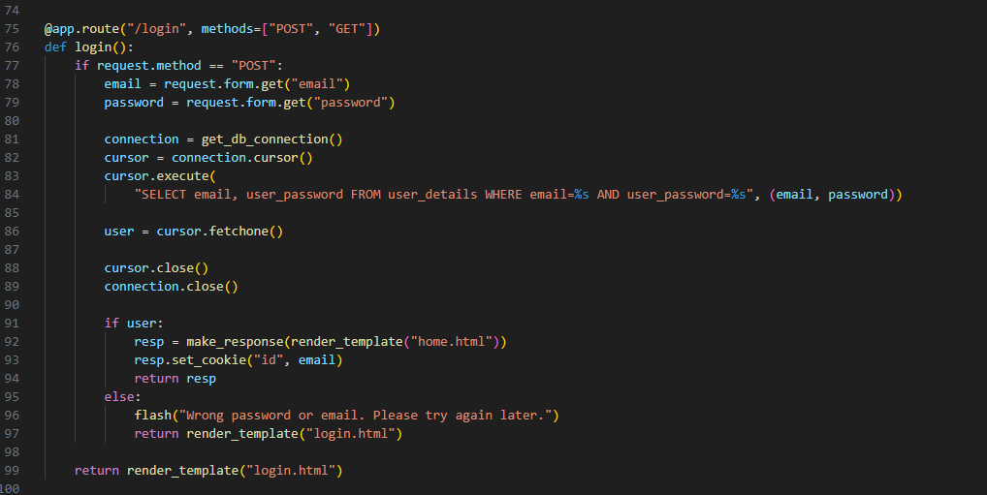

## 3.3 Content Posting

My system accept three content format which are: Text content,video content and image content.

When my server receive the content from the user, It checks whether there was file included before updating the content in the database. If the content contains file data(video or image), the system will save the file inside uploads folder and the file path inside the database (mysql).

­­

## 3.4: Database Implementation

### 3.4.1 Normalization

#### 3.4.1.1 .1NF

Id

User_name

Email

User_password

Date_joined

Post_id

Title

Post

Date_posted

Category

Likes

Myfile

Replyid

Reply

Postid

#### 3.4.1.1 2NF

##### User_details table

Id

Email

User_password

Datejoined

##### Posts table

Id

Title

Post

Date_posted

Category

Likes

Myfile

##### Reply table

Id

Reply

#### 3.4.1.3 .3NF

##### User_details table

Id

User_name

Email

User_password

Date_joined

##### Posts table

Id

Title

Post

Date_posted

Category

Likes

myfile

User_id

##### Reply table

Id

Reply

Post_id

User_id

I used MySQL database in my system

Why I prioritized it:

* It is easy to learn and to write queries
* It is simple to understand and to configure with the code
* It is popular, this makes it easy to access learning resources
* It is faster
* It is secure compared to other databases like sqlite.
* It support many languages and it also support many operations at the same time.

### 3.4.1 Database Tables

The figure below represent the user details table

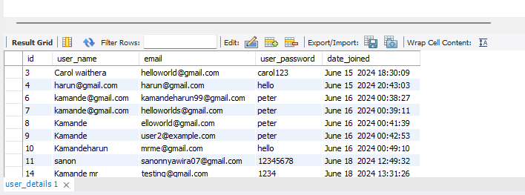

The table below represents Post table

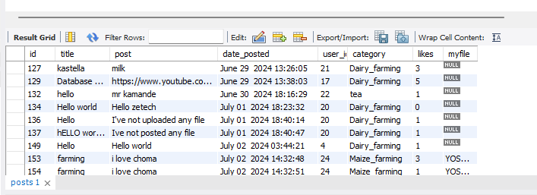

The table below represent reply table

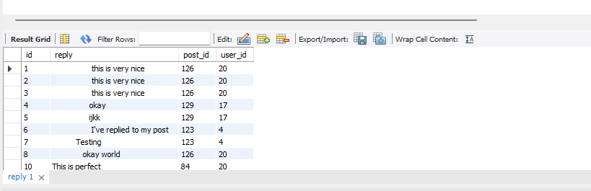

## 3.4.2 System-to-Database Integration

The figure below represents the code that is integrating my system to mysql database.

As shown in the figure below, get_db_connection is the function connecting the system to the database incase it is invoked. In the figure below I’ve applied environment variable to hide my password credentials.

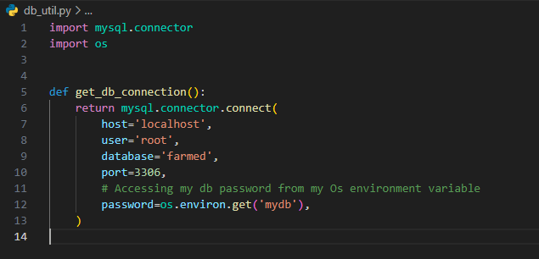

The figure below shows how the login code is linked with the database

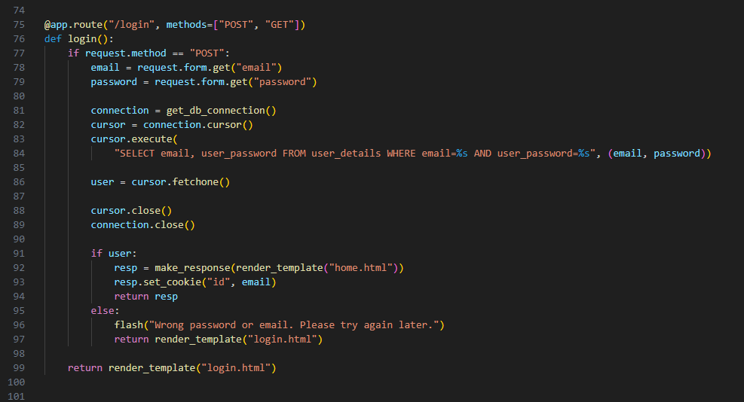

In the figure above the database connection was done in line 81, This is where we have invoked the database connection function.

# **CHAPTER FOUR: CONCLUSION AND RECOMMENDATIONS**

## 4.1 conclusion

In Farm-ed (my project) system, One can be able to create account using a unique email, login using the same credentials. User can be able to post his content or his concern in three forms which are Text form, image form and video form. Any user in the system can be able to post a reply and like someone else post and as a result this makes my system interactive. Any user can delete or edit his/her own post. I’ve also achieved some security measures such as cookie implementation and the use of environment variable. I’ve used environment variable to hide my database password on the other hand ive used cookies to store data that is frequently requested by the system.

## 4.2: Recommendation

If someone else was to develop a project similar to Farm-ed, I would advise them to carefully plan and document their development process, focusing on scalability and user experience. During my project, I faced challenges such as ensuring data security and managing user interactions efficiently. Utilizing technological tools like Python's Flask framework for backend development and a robust database management system (DBMS) like MySQL helped in achieving a seamless and secure application. I also recommend using AJAX to enhance the user experience by enabling asynchronous data updates, which makes the application more dynamic and responsive. Additionally, I used cookies and environment variables to enhance security and manage frequently requested data efficiently.

# References

Der Kamp, (2022, July 13). “Importance of Agricultural Education”:

Alhambra US.chamber. https://alhambrauschamber.org/blog/the-importance-of-agricultural-education

Rober.K, (2023, November 12). “eLearning in Agriculture Industry”:

Learnexus. https://learnexus.com/blog/elearning-in-agriculture-industry/#:~:text=Benefits%20of%20eLearning%20in%20Agriculture%201%20Accessibility%20eLearning,cost-effective%20than%20traditional%20education%20and%20training%20methods.%20

Luck.C, (n.d.). “5 Reasons why Agriculture Education is important”:

Michigangrown. https://michigangrown.org/5reasons/

Hillary, (2023, July 5). “Advantages and disadvantages of agriculture”:

Techbullion. https://techbullion.com/advantages-and-disadvantages-of-agriculture-exploring-the-pros-and-cons/

Gore.E, (2024, February 29). “Why eLearning works. Benefits of eLearning ”:

Elm learning Lab. https://elmlearning.com/blog/benefits-of-elearning/